Ping - Compulsory Assignment #1

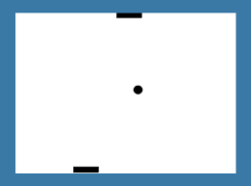

Put your own game image here!

**Handed-in by**

1. **Rip**
2. **Rap**
3. **Rup**

**Date: 16/9-2015**

# Table of Content

Table of Content 2

1. Introduction 2

2. Functionality 2

3. Internal design 2

4. Evaluation 2

# Introduction

Here you present the project; what, where, who. Initial ambition and plan can be briefly described.

# Functionality

The functionality of the game must be described. You may refer to requirements in the assignment (1-7 mandatory and a) to g) optional).

# Internal design

Present one or more UML class diagrams for your game. Remember to comment your diagrams.

# Evaluation

Was it a good project? What did you learn? What to do better, to improve next time?